**This is what I have learned in Statistics from “Khan Academy”**

Basics: Descriptive vs inferential statistics, continuous vs discrete data, nominal vs ordinal data

▪ Basic plots: Histograms, pie charts, bar charts, scatter plot etc.

▪ Measures of central tendency: mean, median, mode

▪ Measures of dispersion: variance, standard deviation

▪ Probability basics

▪ Distributions: Normal distribution

▪ Correlation and covariance

▪ Central limit theorem

▪ Hypothesis testing: p value, confidence interval, type 1 vs type 2 error, Z test, t test, ANOVA

**Three measures of Central Tendency(Mean, Median and Mode).**

**Mean: preferred when there is no outlier. (Outlier -the only odd value, will pull mean toward it)**

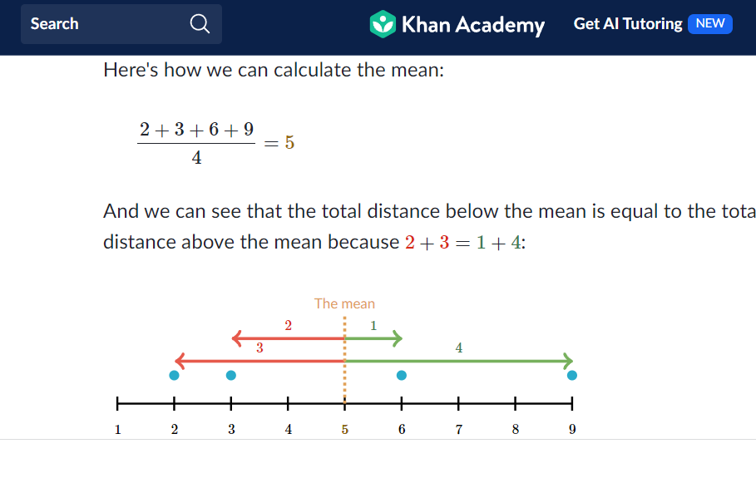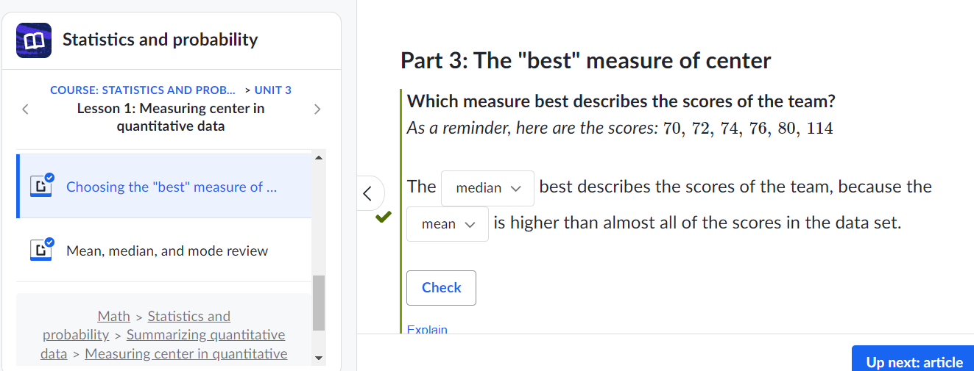

**Biased and unbiased sampling distribution and central limit theorem:**

* **Sampling distribution of mean is approximately normally distributed when sample size gets large enough.**

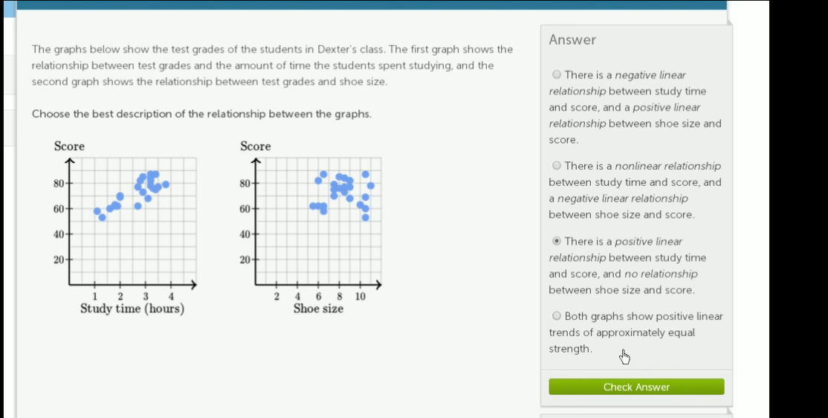

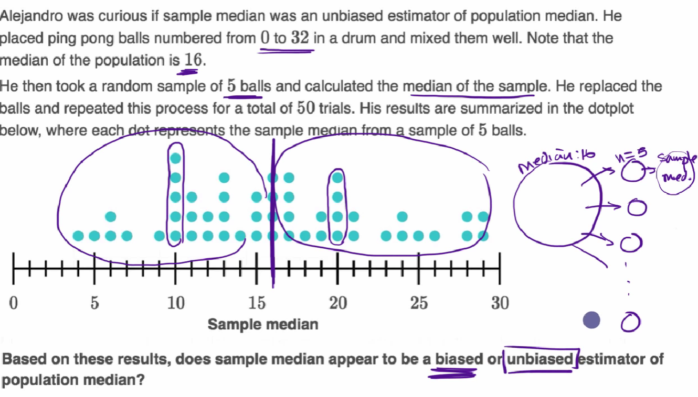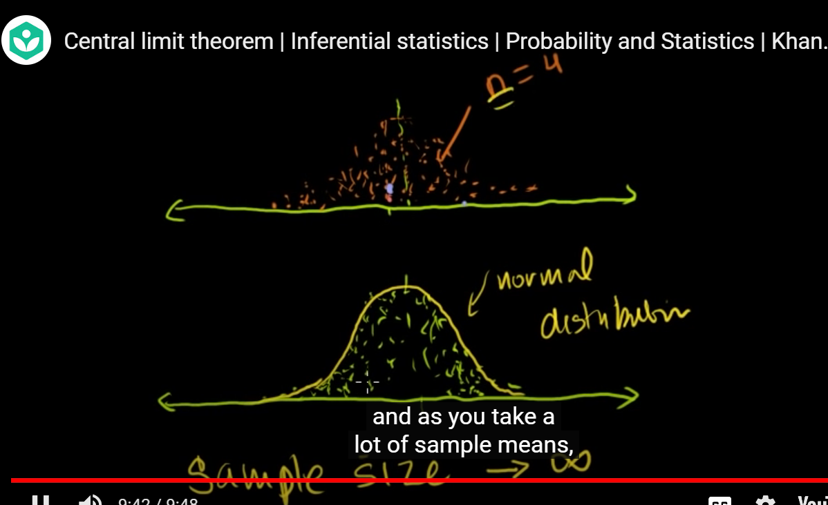

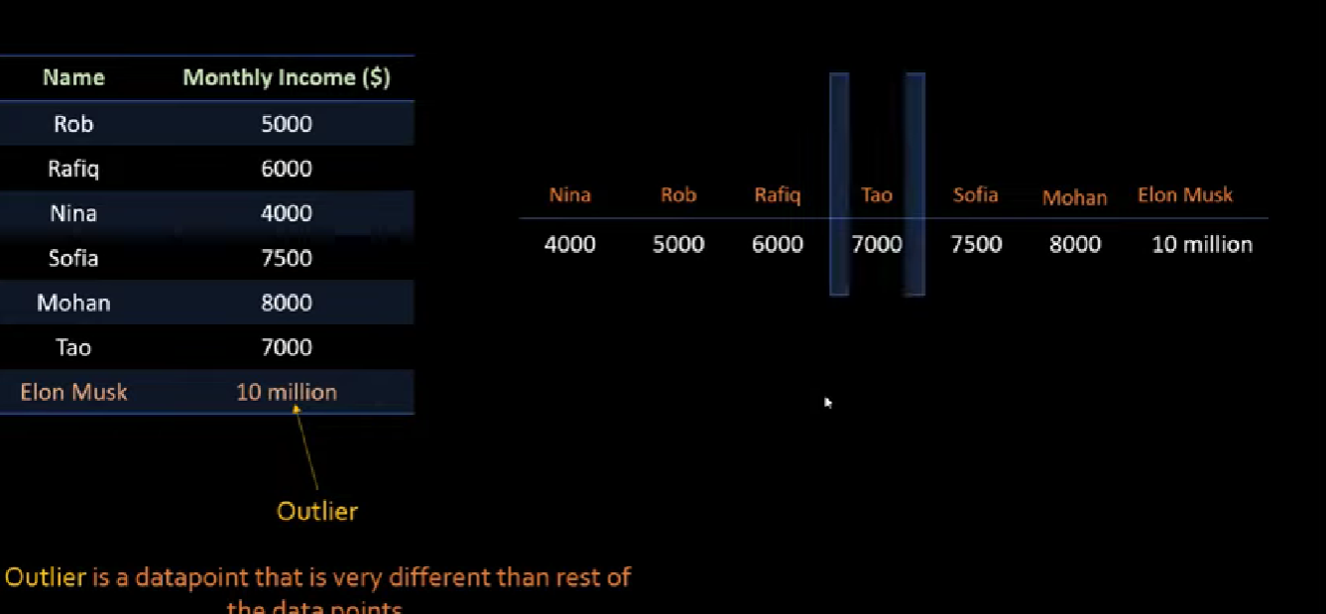

**Sampling distribution of proportion, estimation, confidence interval estimation for mean and proportion and determination of sample size:**

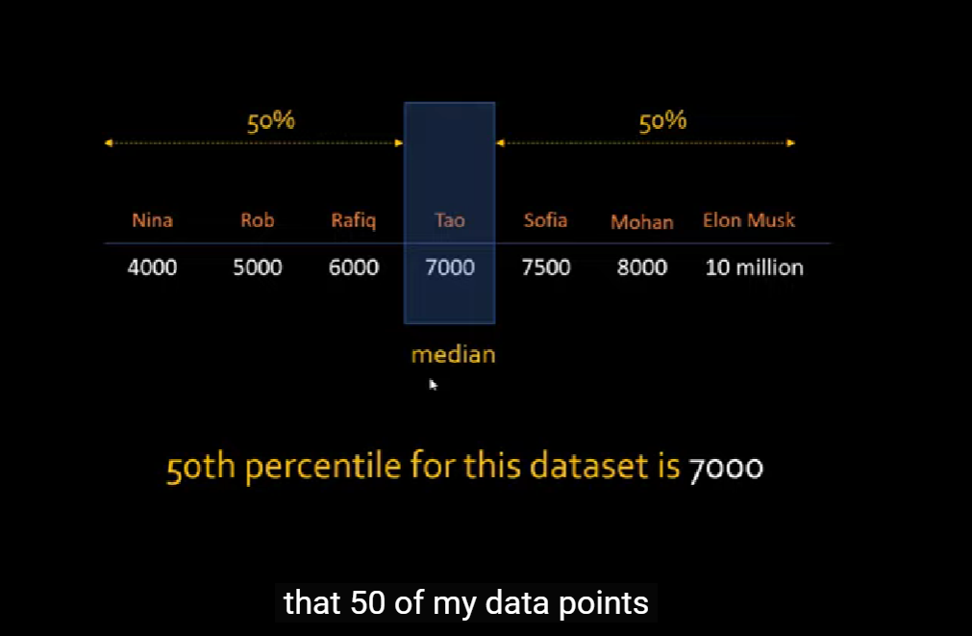

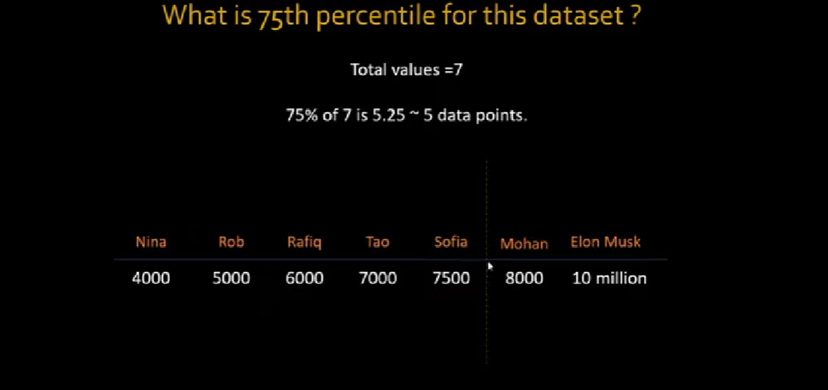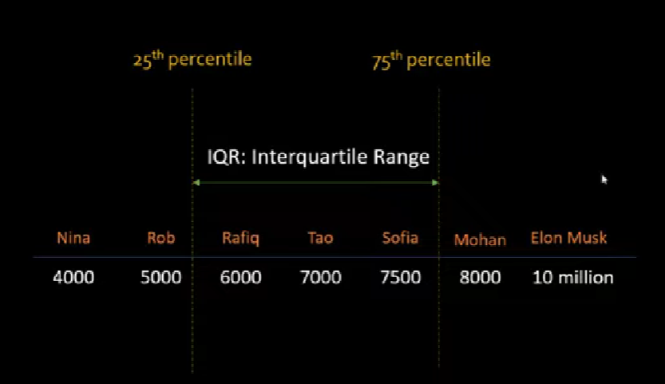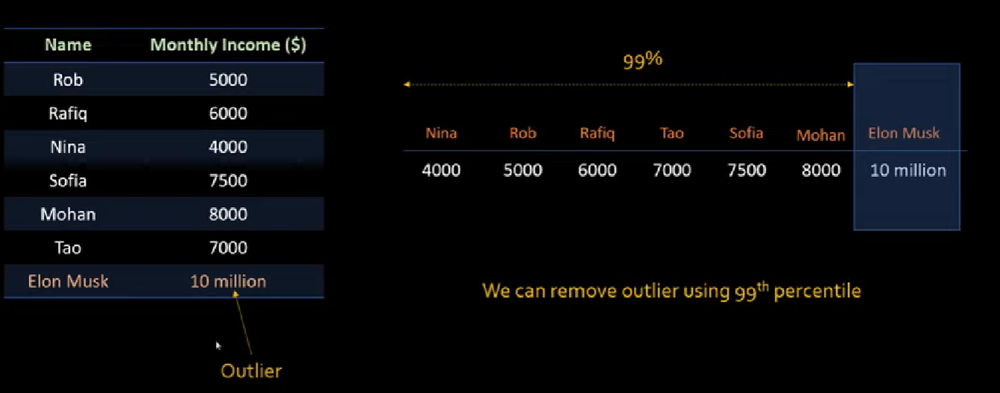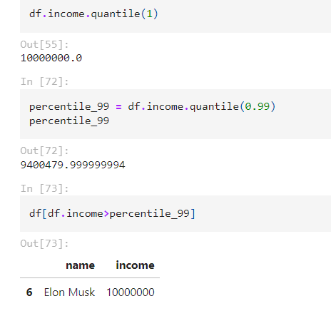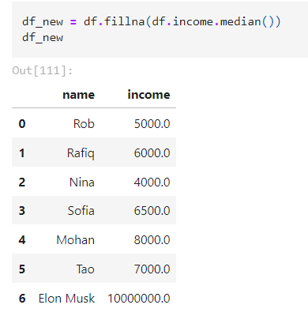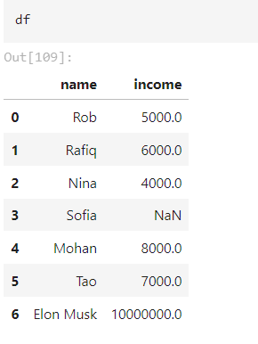

**Confidence intervals and basics of hypothesis testing**

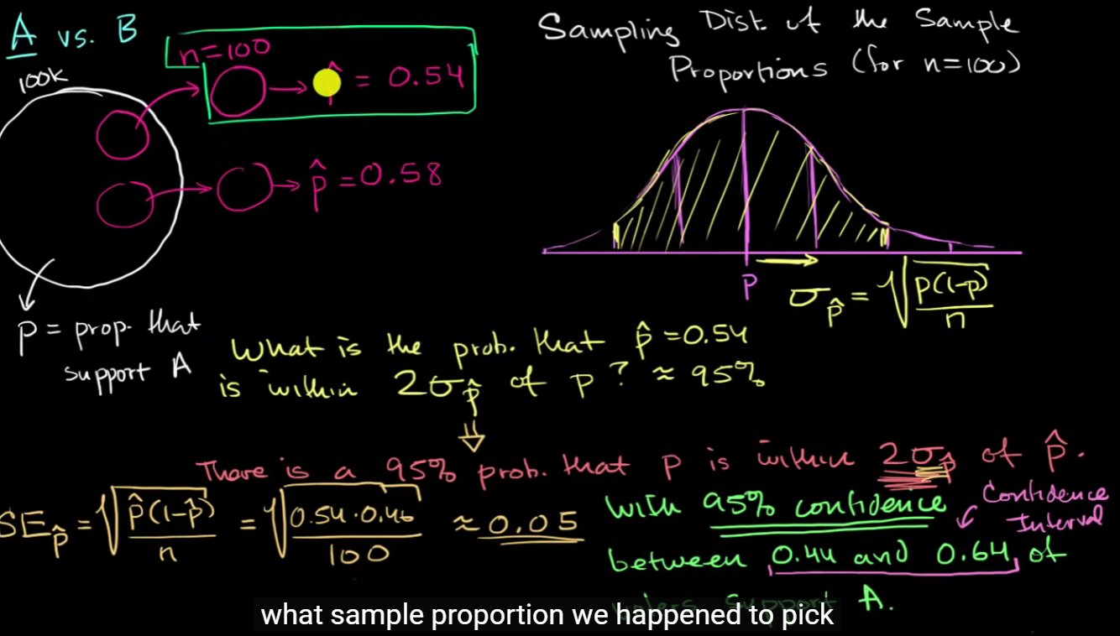

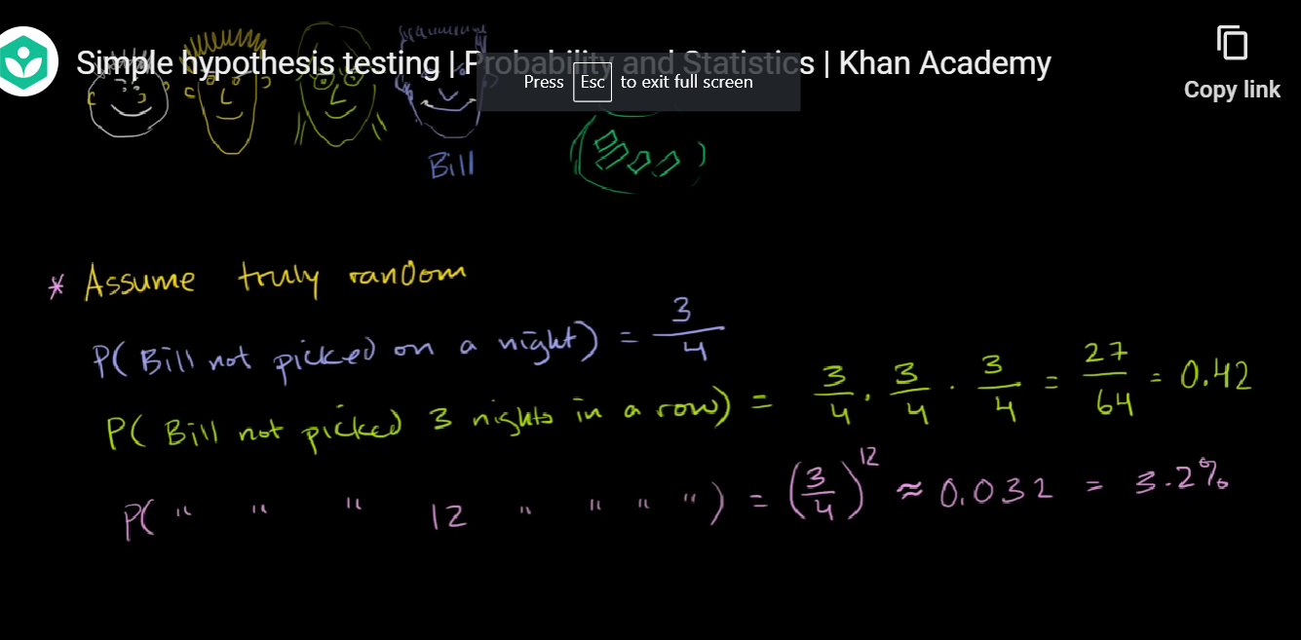

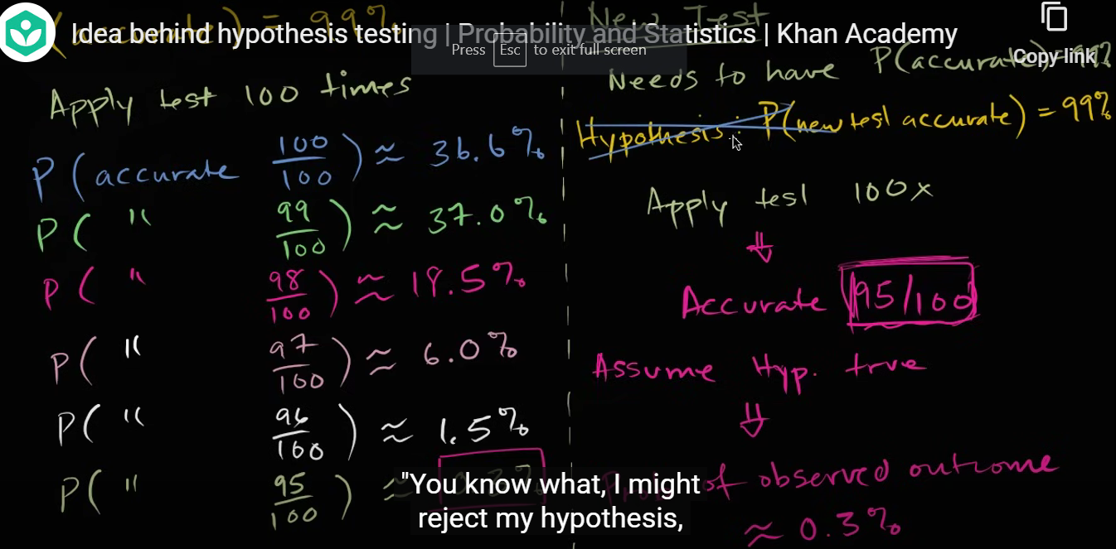

**Types of statistical hypothesis, errors in hypothesis testing and level of significance**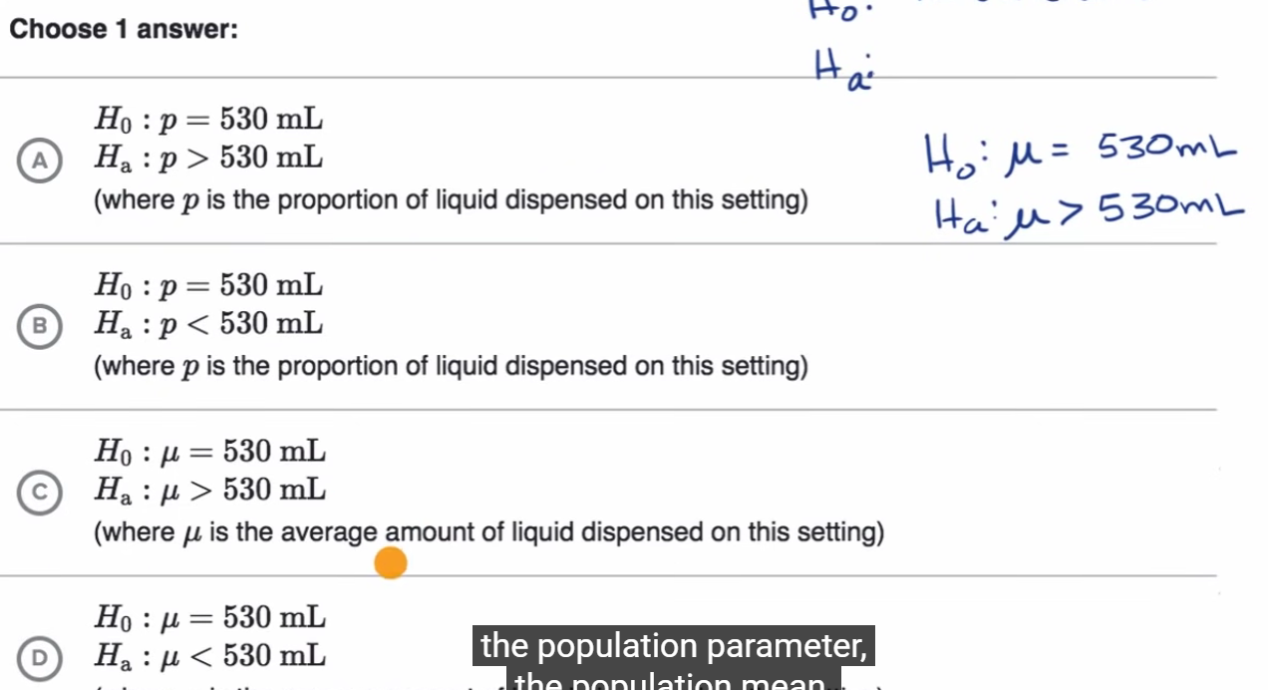

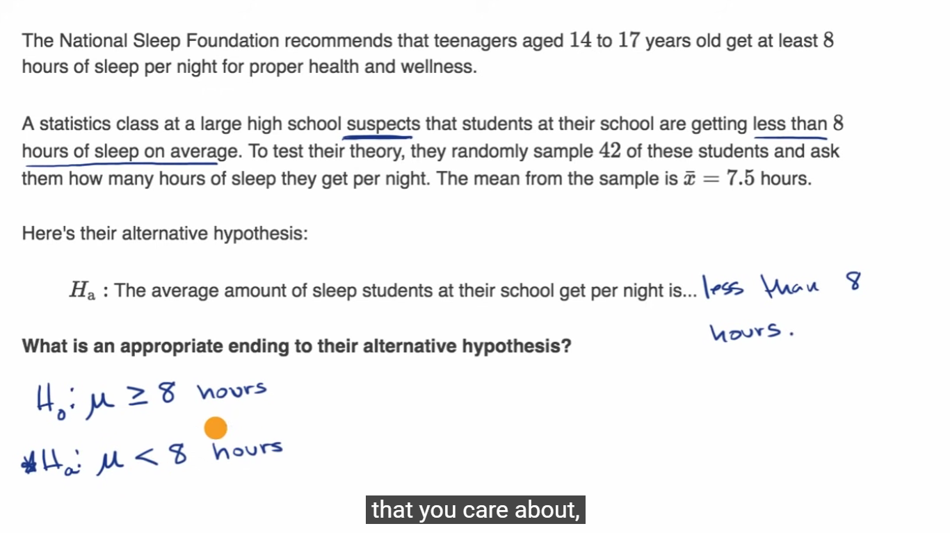

**P-values and significance test**

**Comparing p values to different significance levels**

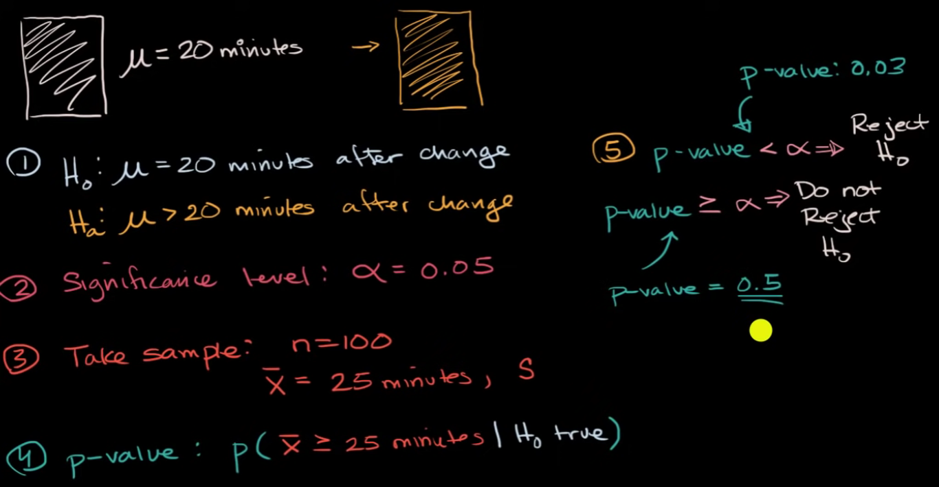

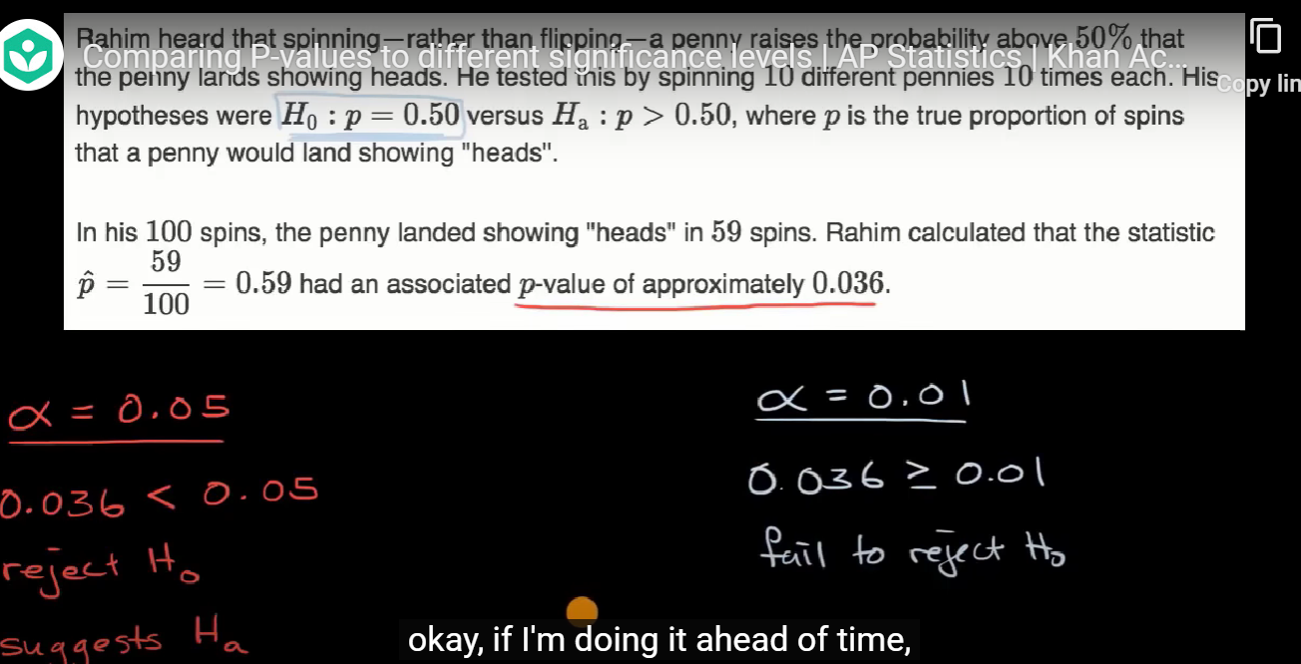

**Estimating p value from simulation**

**Null hypothesis rejection and acceptance on basis of level of significance**

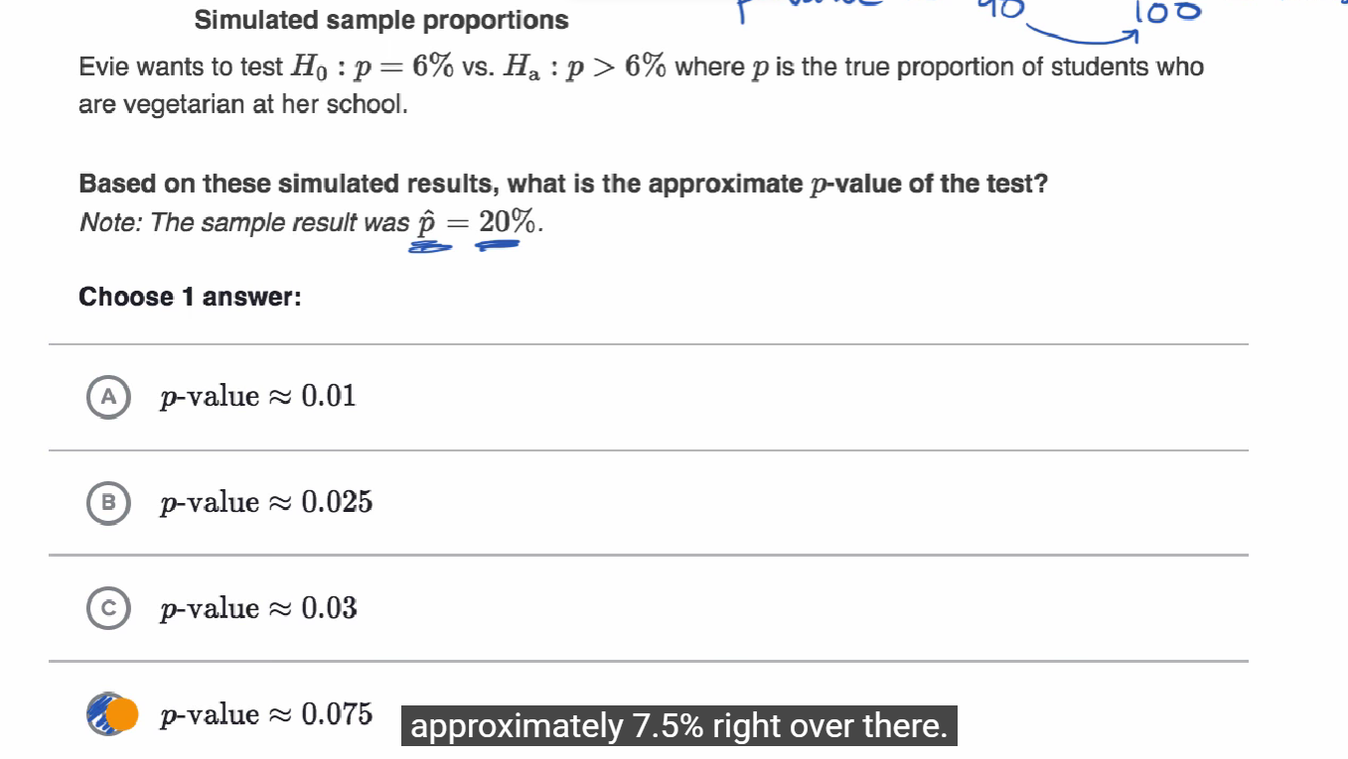

* **Using P-values to make conclusions**

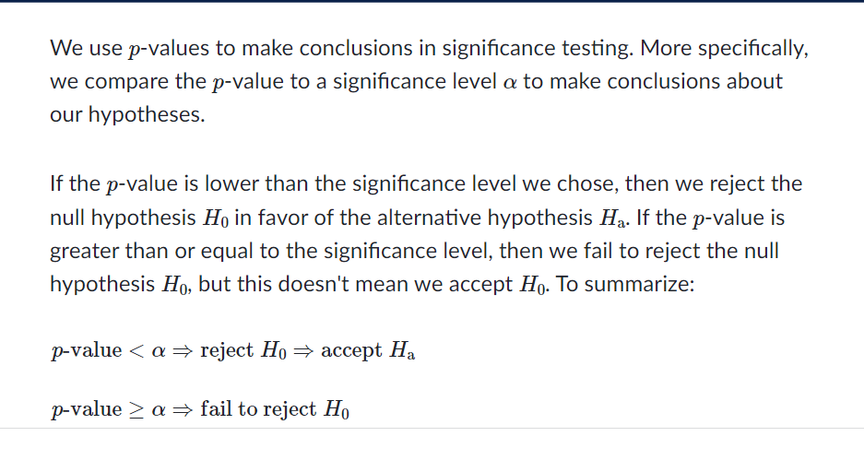

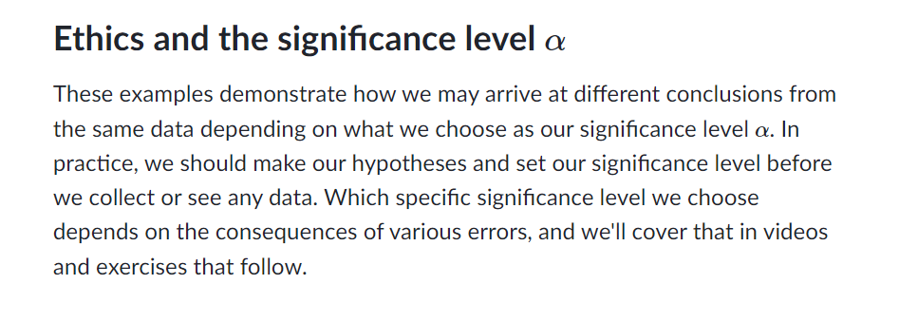

**Constructing hypotheses for a significance test about a proportion**

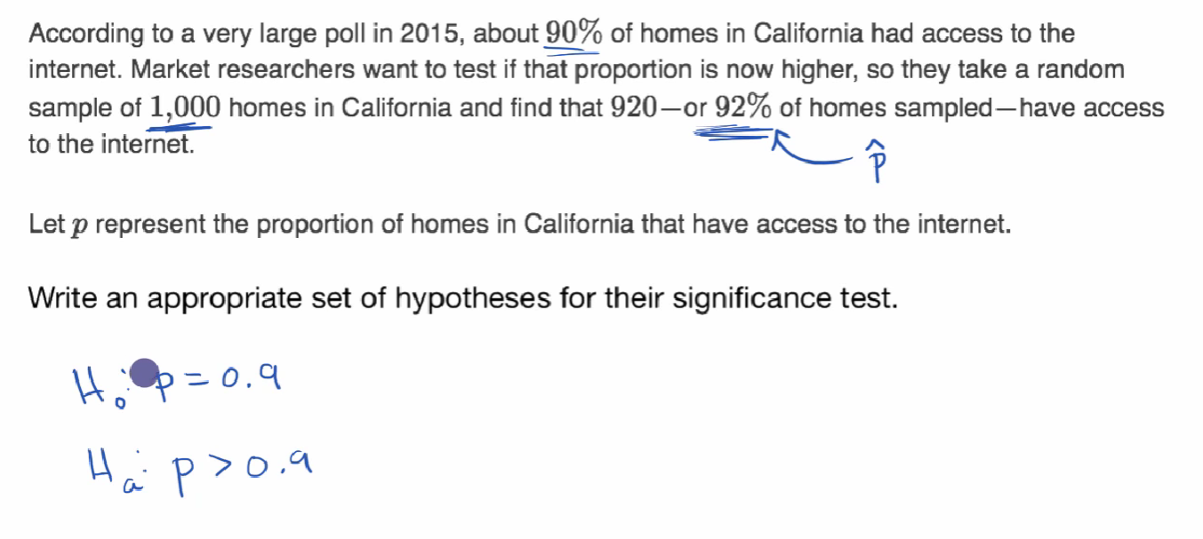

**Conditions for a z test about a proportion**

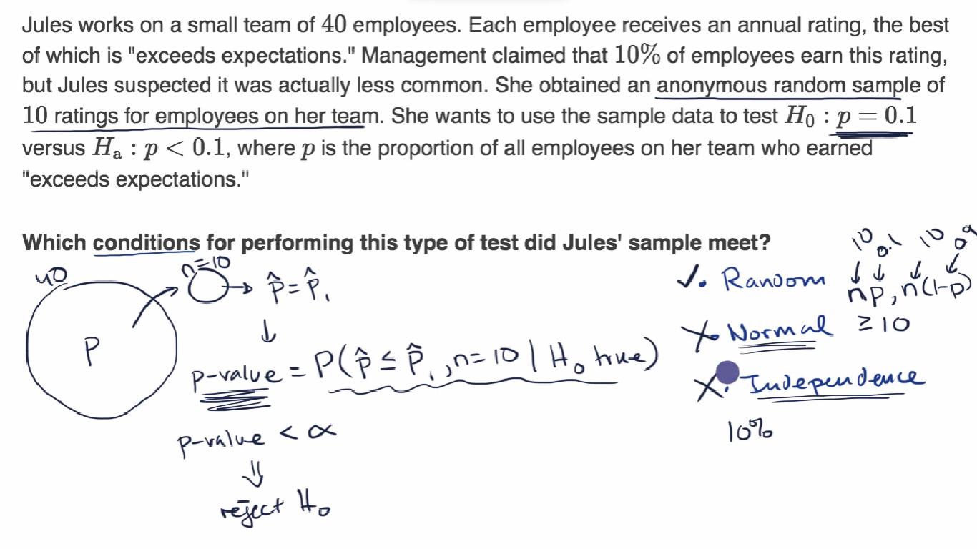

**Conditions for inference on a proportion**

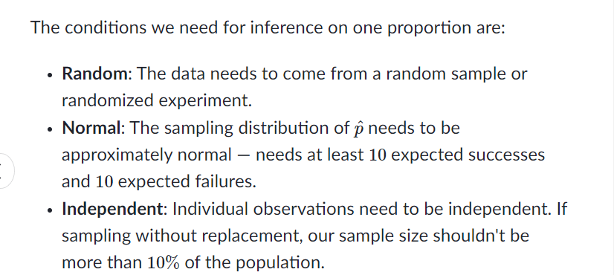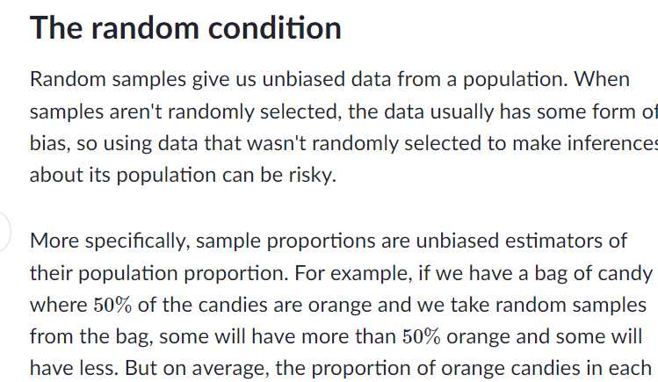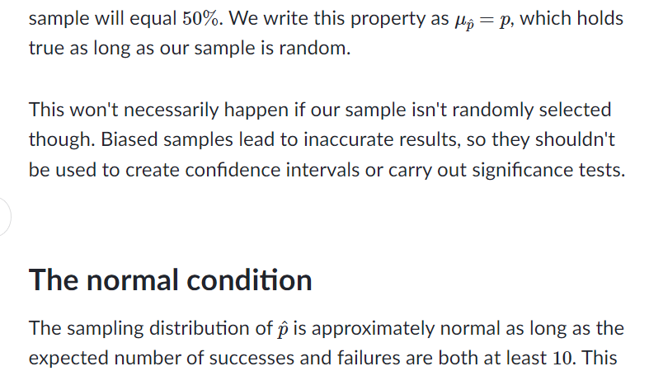

**ANOVA(analysis of variance)**

* **Calculating SST (total sum of squares)**
* **Calculating SSW and SSB (total sum of squares within and between)**

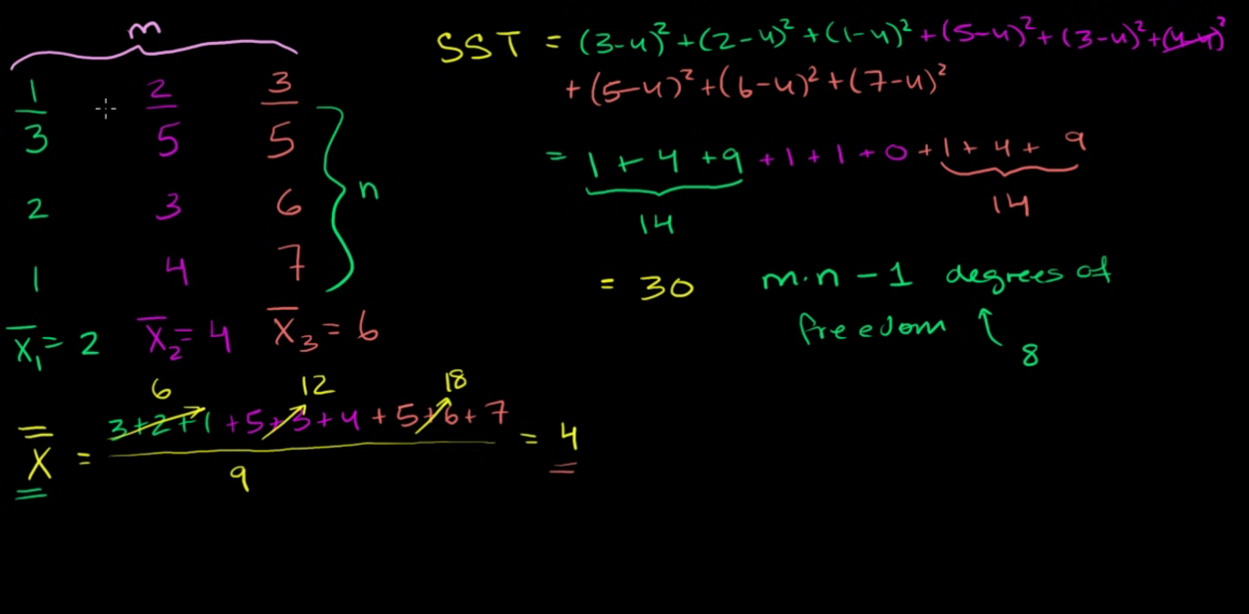

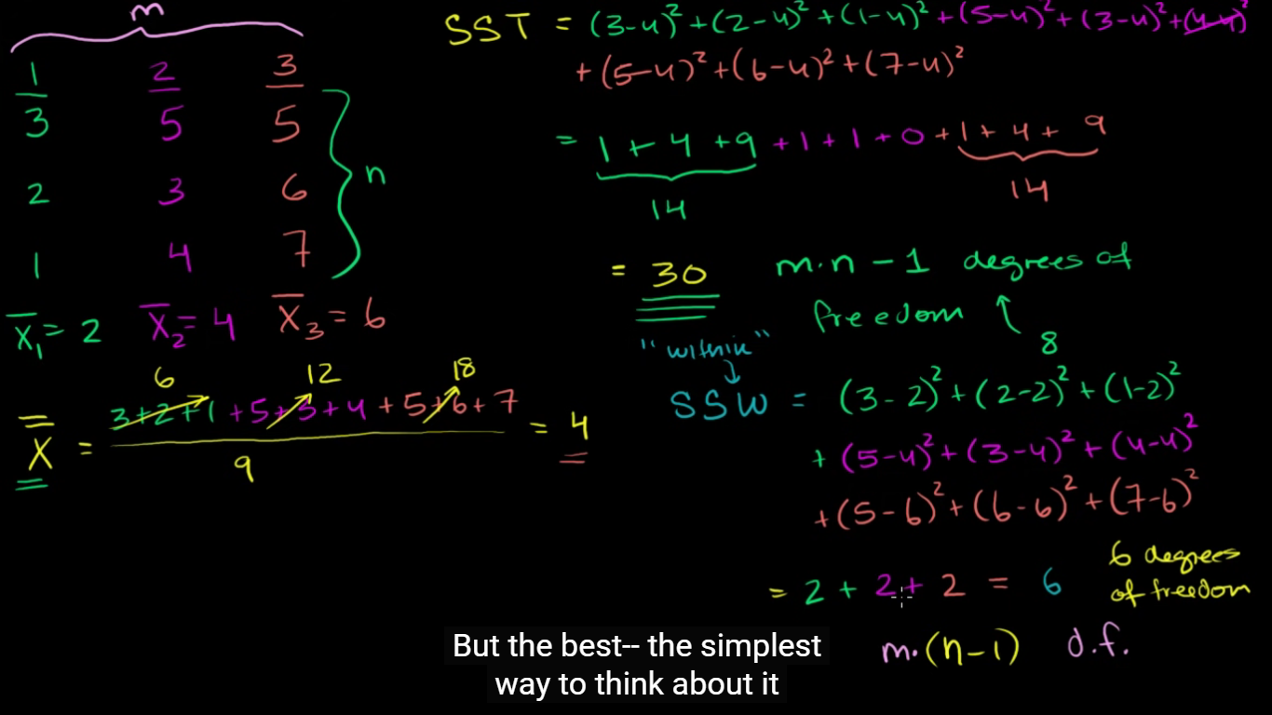

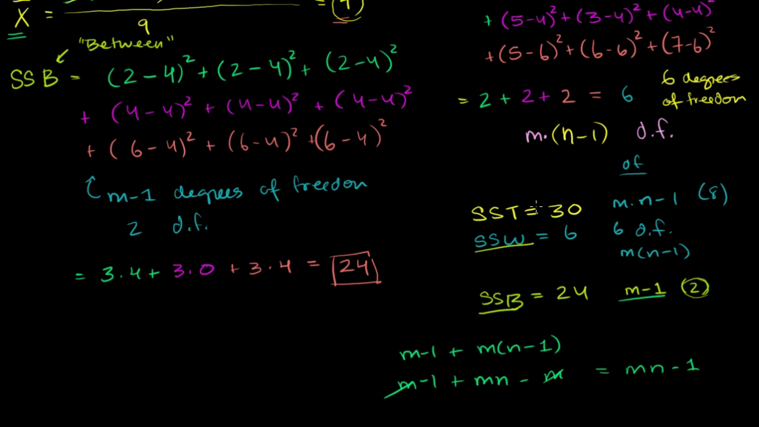

**ANOVA 3: Hypothesis test with F-statistic**

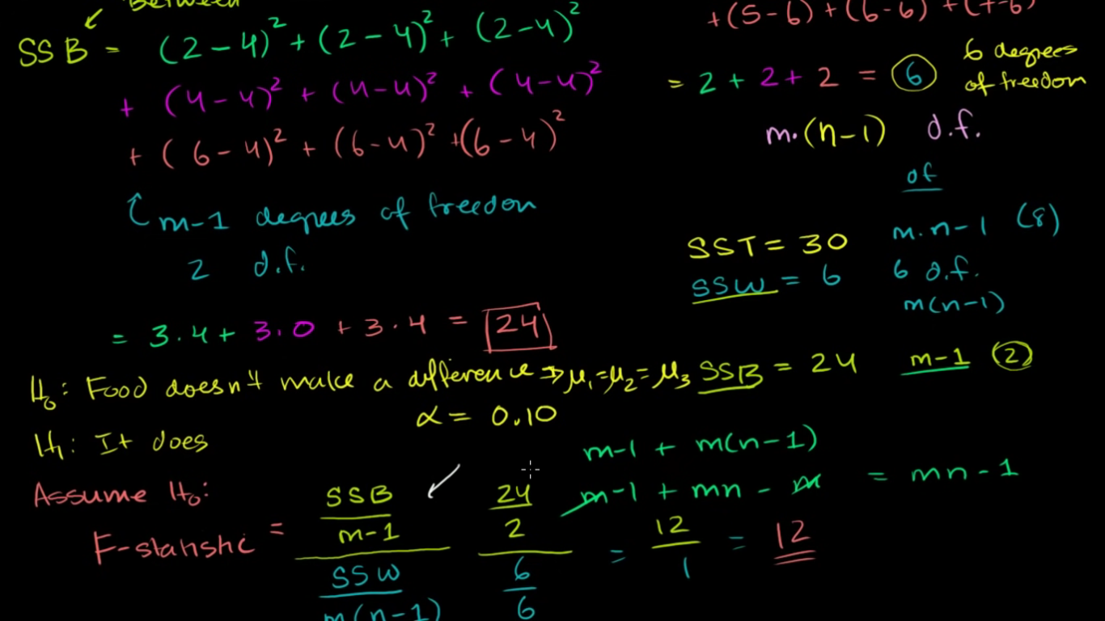

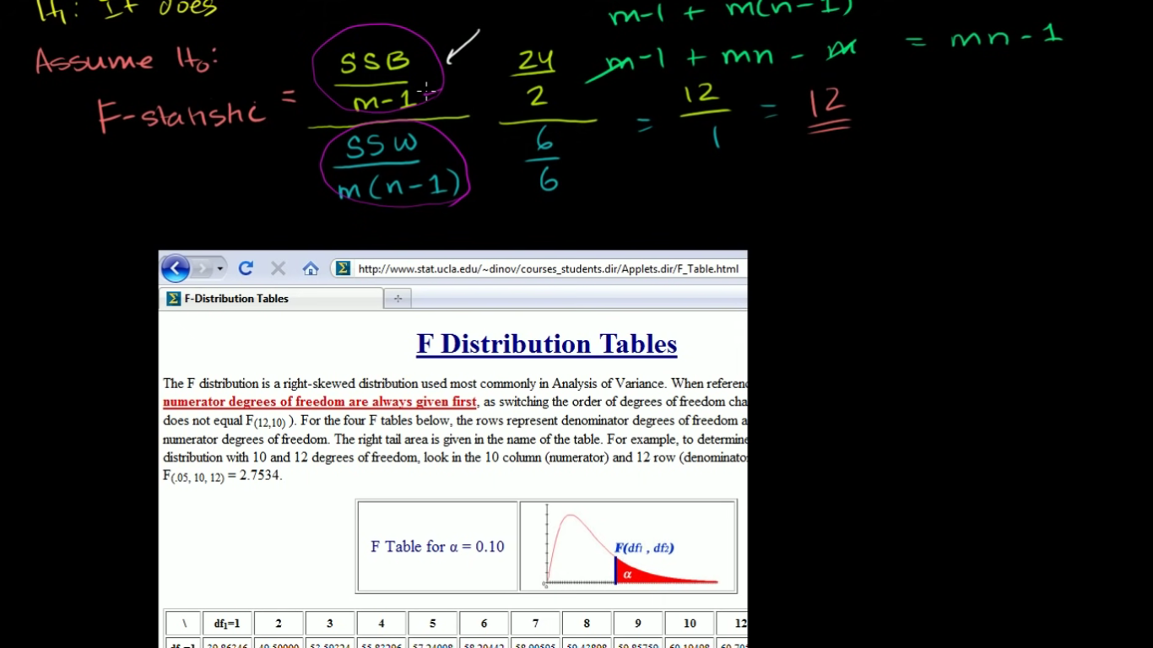

* **Why we use S.D over Mean Absolute Deviation?**
* **How Normal Distribution can be used in Data Analysis?**

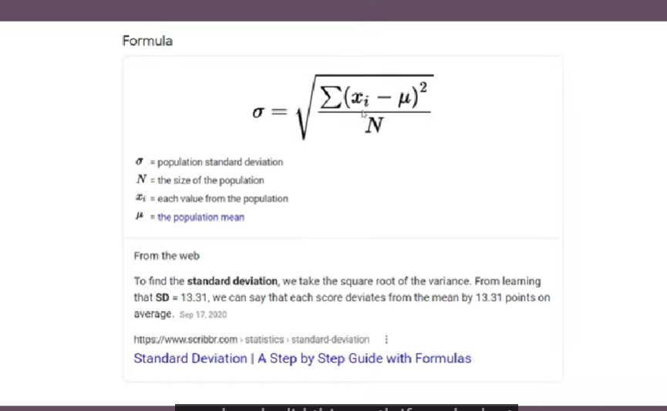

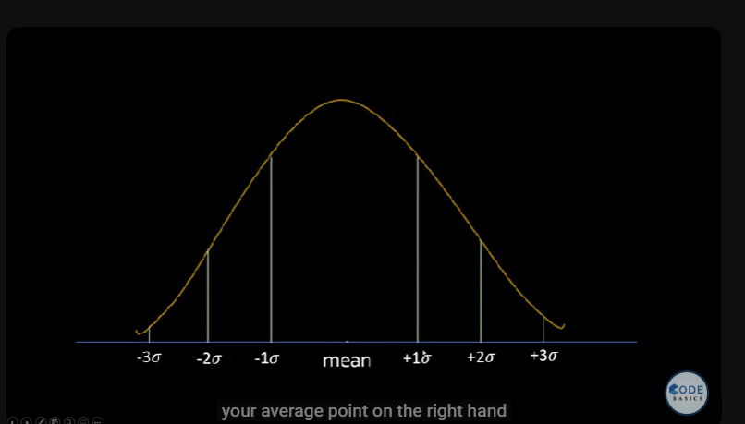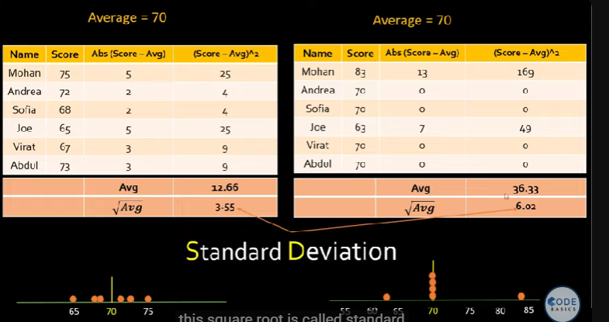

**How Z-score can be used to remove outlier?**

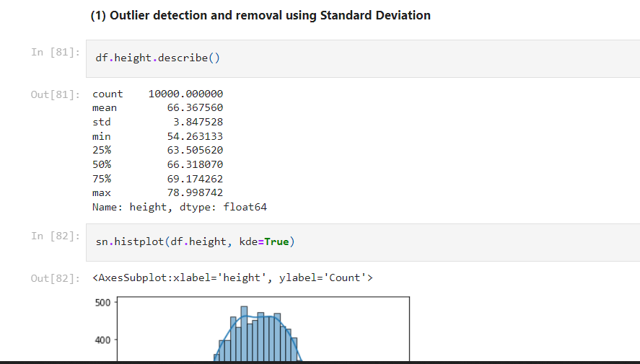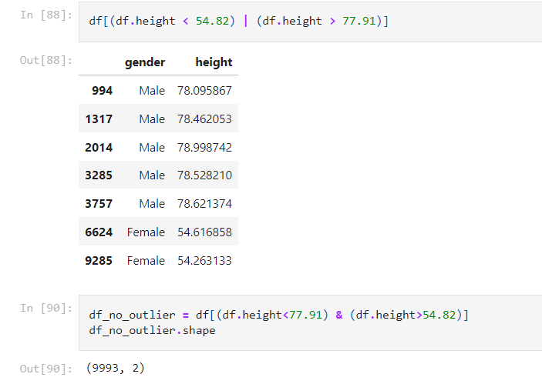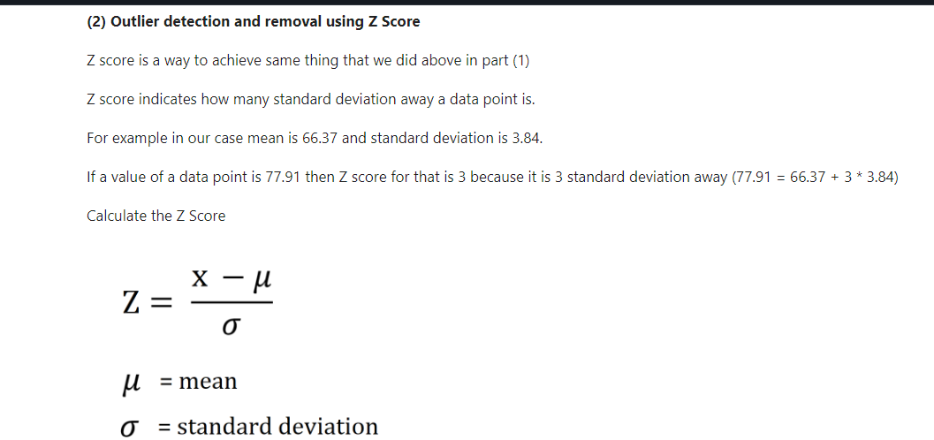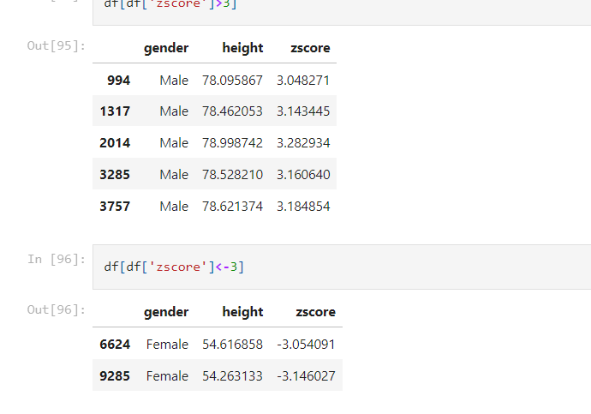

* **What is logarithm?**
* **Log transform in ML**
* **Where are logarithm used?**
* **Log Normal Distribution**

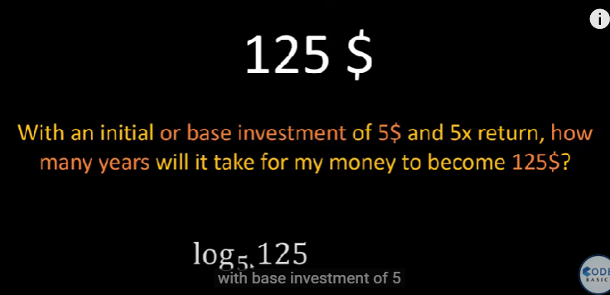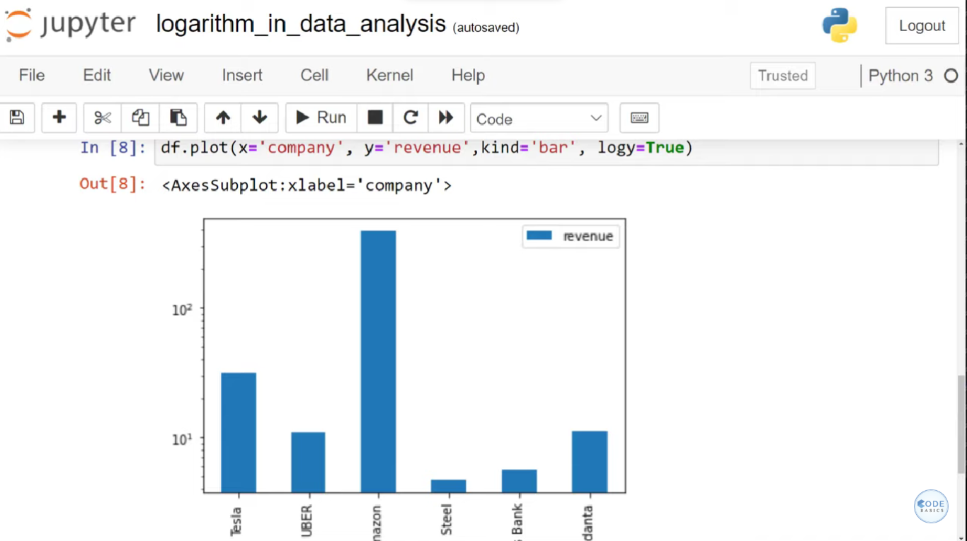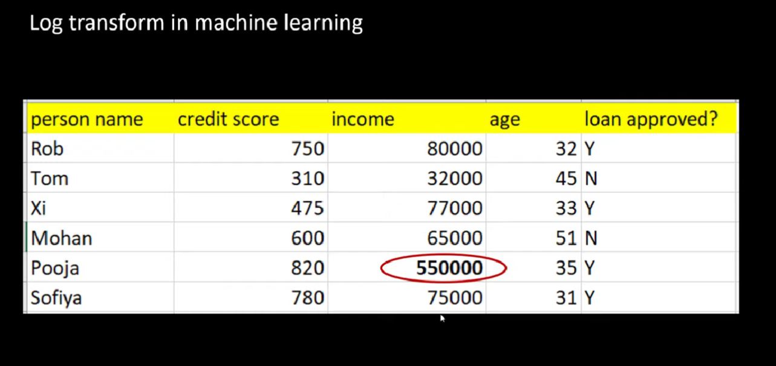

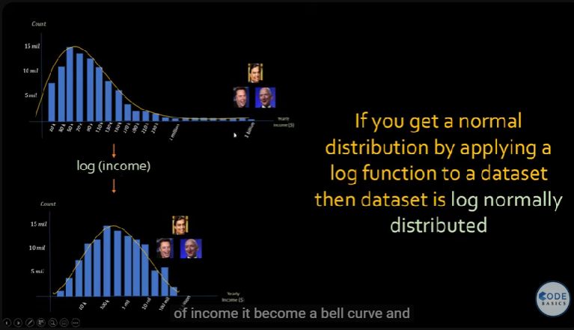

* **used percentile to remove outlier**
* **learned cosine similarity to check document similarity**

